**Namaste React**

Emmet – In vscode Emmet generates useful code for us

First Task- to put html code into our .html file using react

Our browser don’t have react, so we need to import the react library hosted on CDN

Then our browser will be able to understand react code

**REACT -** A JavaScript library useful to develop User Interfaces, basically A file having code written in JavaScript

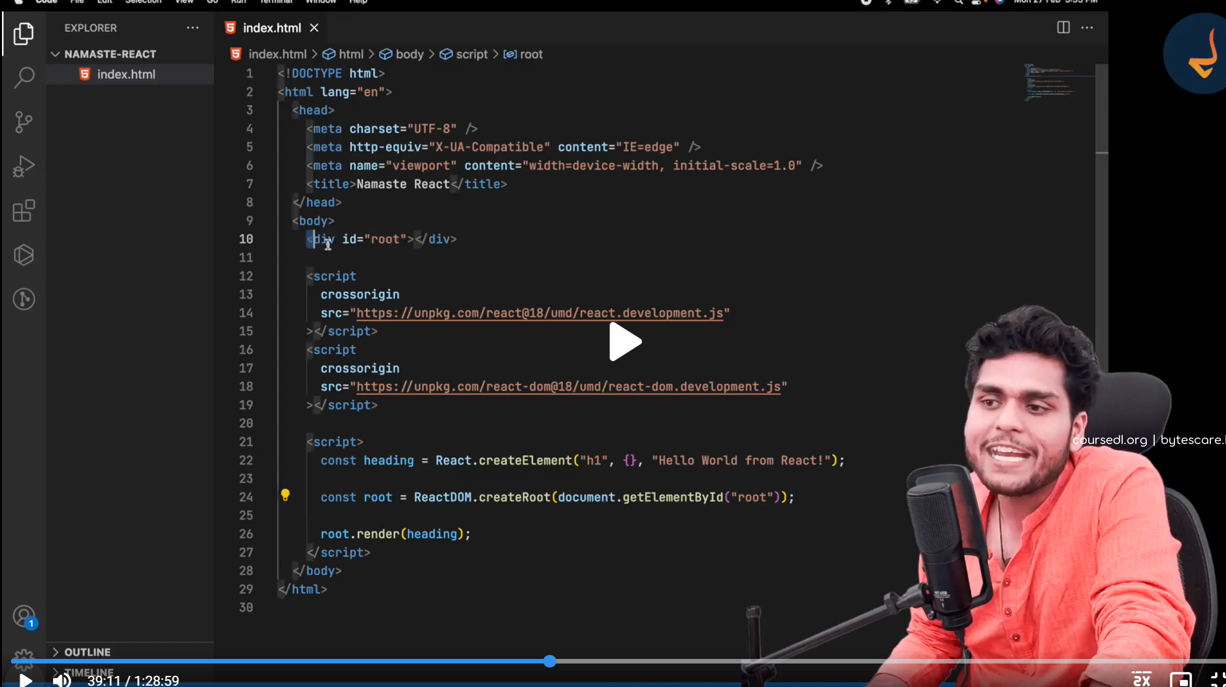

Note – before rendering the elements into DOM, we need to create the root where all the elements get rendered

Note2 – We have

*React was made to optimize the expensive operation in a web page (which is manipulating the DOM). We will use the React to manipulate our DOM*

**Behind The Scene**

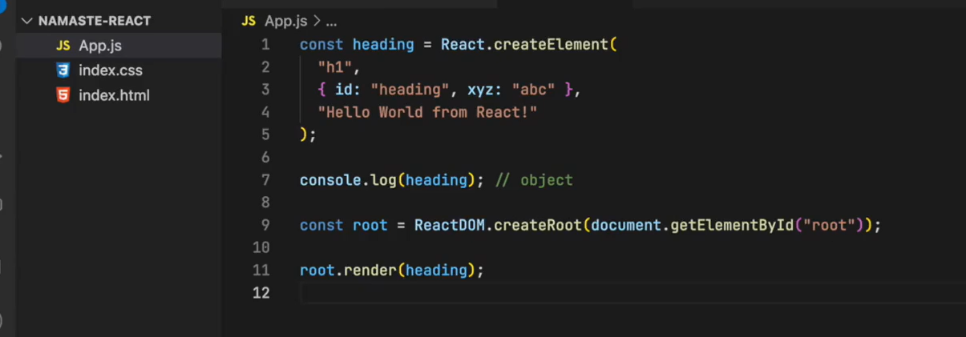

* In the create element we passes the attributes of the tag
* React.createElemement creates a JavaScript object not a tag (h1 here)

Here is the object we are getting  
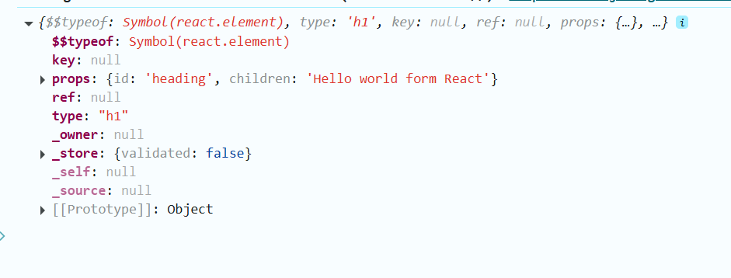

* Render() has responsibility to take this object convert it into the html element and put up on the DOM

**Creating Nested Structure of HTML in React**

